[H1] **Download your IRS 1095-B tax form**

Download your 1095-B IRS tax form to show proof that you had VA health coverage in the most recent tax year.

[Dynamic widget: Content changes as Veteran interacts with page]

**Please sign in to download your 1095-B tax document**

Sign in with your existing **Login.gov**, **ID.me**, **DS Logon**, or **My HealtheVet** account. If you don’t have any of these accounts, you can create a free **Login.gov** or **ID.me** account now.

[button] Sign in or create an account

[End dynamic widget]

[H2] **How to use your form**

Keep this form for your records. Due to changes in the Affordable Care Act (ACA), you no longer need a 1095-B tax form to file your federal taxes.

[Learn more about the ACA and your VA health care](http://preview-prod.vfs.va.gov/health-care/about-affordable-care-act)

**Note:** Some states have their own individual health care law. If you  don’t have health coverage, you may be charged a fee when you file your  state taxes.

As of January 2022, these states and the District of Columbia have their own health care law:

* California
* Massachusetts
* New Jersey
* Rhode Island
* Vermont

[Learn more about state health care laws on HealthCare.gov](https://www.healthcare.gov/taxes/no-health-coverage/)

[H2] **How to update your form**

If you need to correct or update your address or other information on your form, call us at 877-222-8387 (TTY:711). We’re here Monday through Friday, 8:00 a.m. to 8:00 p.m. ET.

**Note:** If we need to change your address, it may take us up to 4 business days to have your revised form ready to download. Other changes to your personal information can take up to 20 days to process.

[H2] **More resources**

* [**The Affordable Care Act (ACA) and your VA health care coverage**](http://preview-prod.vfs.va.gov/health-care/about-affordable-care-act)

Find out what you need to know about the ACA—also known as the health care law—and your health coverage.

* [**How to change your legal name on file with VA**](http://preview-prod.vfs.va.gov/resources/how-to-change-your-legal-name-on-file-with-va)

Find out how to change your name at your VA medical center, each VA program office that you receive direct benefit payments from, and the DEERS support office.

* [**How to change**](http://preview-prod.vfs.va.gov/resources/how-to-change-your-legal-name-on-file-with-va) **your address in your VA.gov profile**

Follow our step-by-step instructions on how to sign in, go to your profile, and update your address.

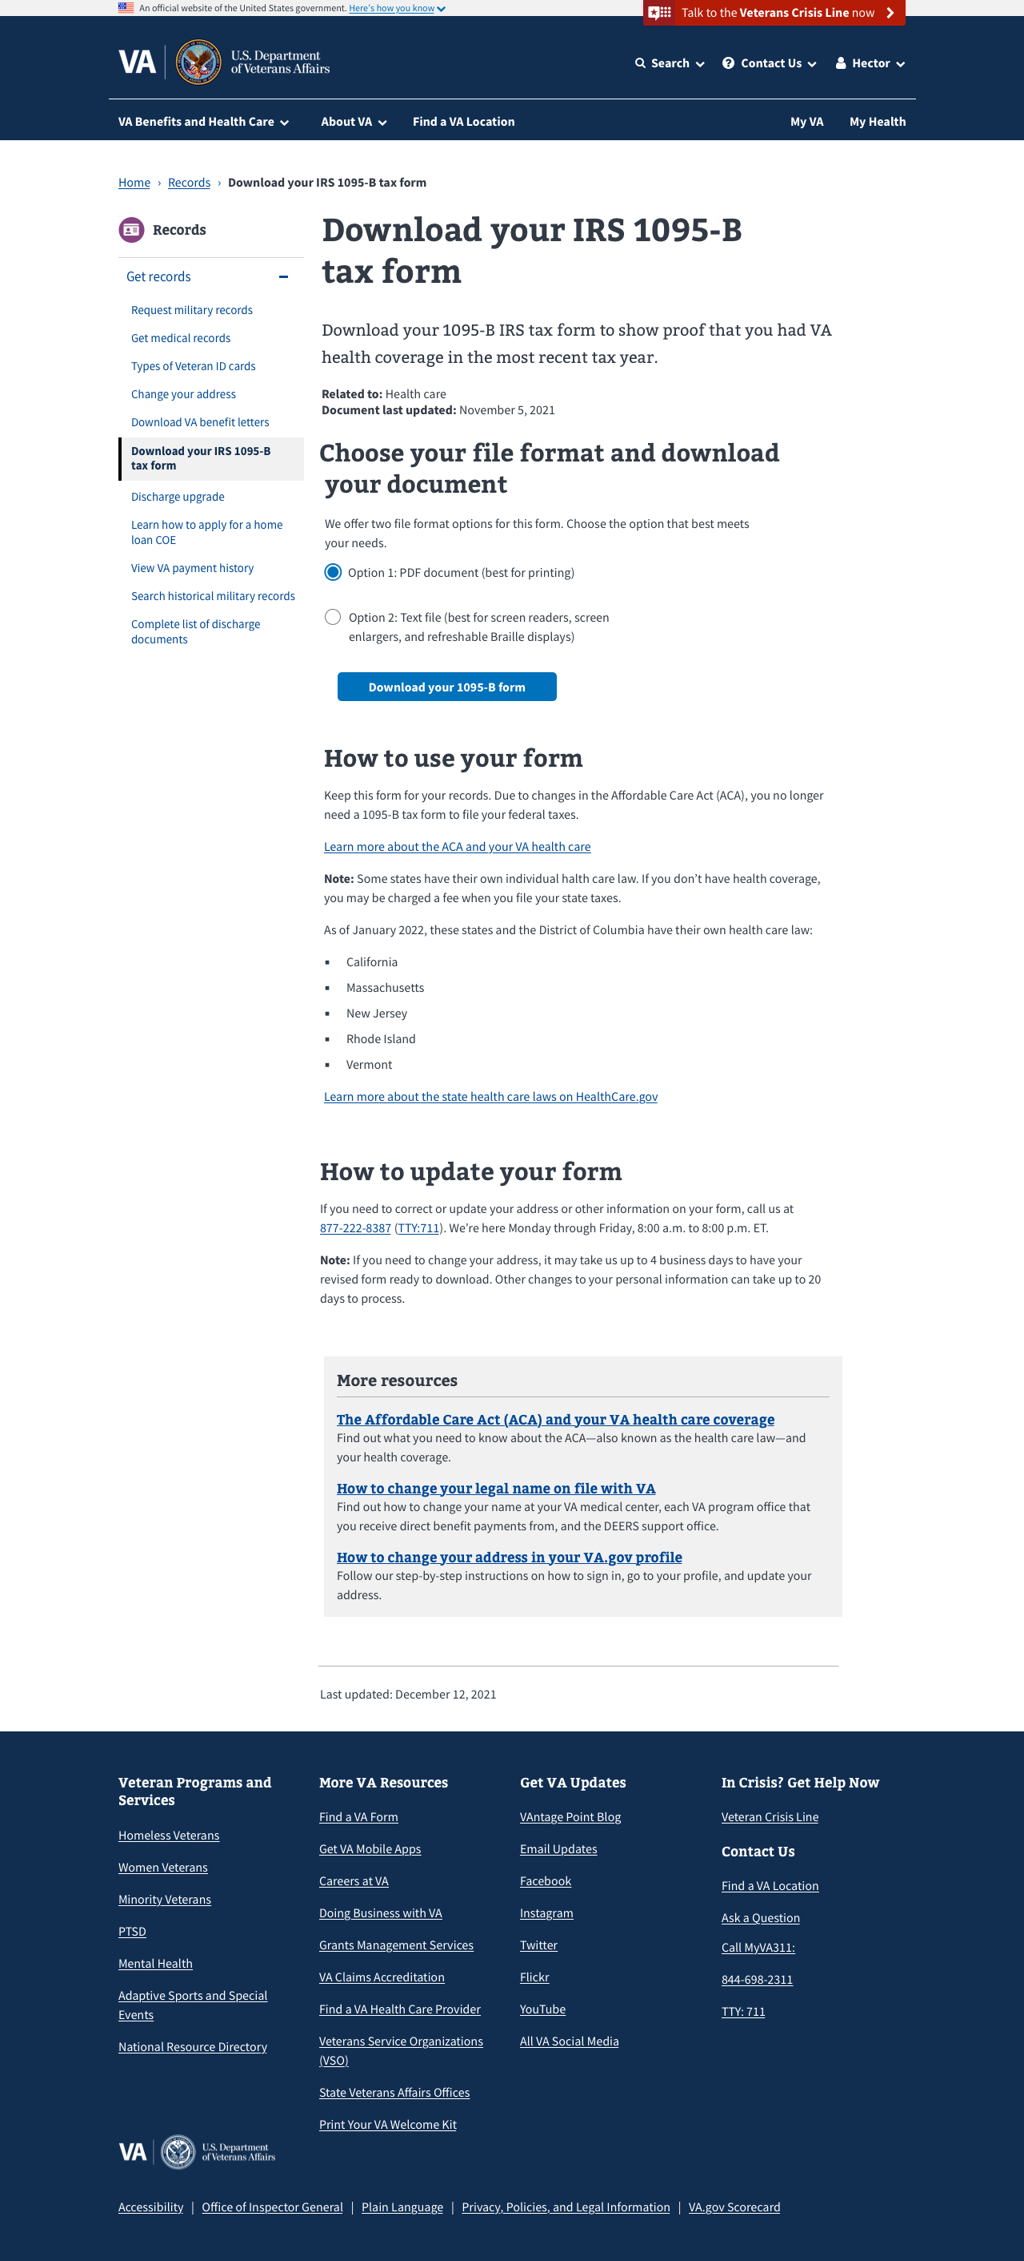

**[Content in dynamic widget that changes and will need translation]**

Download your IRS 1095-B tax form to show proof that you had VA health coverage in the most recent tax year.

**Related to:** Health care

**Document:** [Month] [Day], [Year]

[H2] **Choose your file format and download your document**

We offer two file format options for this form. Choose the option that best meets your needs.

**[radio button]** Option 1: PDF document (best for printing)

**[radio button]** Option 2: Test file (best for screen readers, screen enlargers, and refreshable Braille displays)

**[button] Download your 1095-B tax form**

[H3] **Sign up for paperless delivery**

We mail you a paper copy of your 1095-B form each year. If you want to stop getting paper forms, you can choose paperless delivery. We’ll email you once a year when your new form is ready to download.

**[Action link] Go to your VA.gov profile to choose 1095-B paperless delivery**

**[Additional messages that will need translation]**

**Download complete**

You successfully downloaded your 1095-B tax form. Please check your files.

[MM/DD/YYYY] [HH:MM] [a.m./p.m.]

**You don’t have a 1095-B tax form available right now**

If you recently enrolled in VA health care, you may not have a 1095-B form yet. We process 1095-B forms in early January each year, based on your enrollment in VA health care during the past year.

If you think you should have a 1095-B form, call us at 877-222-9397 (TTY:711).

**We couldn’t download your form**

We’re sorry. Something went wrong when we tried to download your form. Please try again. If your form still doesn’t download, call us at 800-698-2411 (TTY: 711). We’re here 24/7.

Your 1095-B form isn’t available to download right now

Check back later. Or, if you need help with this form now, call us at 877-222-8387 (TTY: 711). We’re here Monday through Friday, 8:00 a.m. to 8.000 p.m. ET.